**BC-2015**

Courbariaux, Matthieu, Yoshua Bengio, and Jean-Pierre David. "Binaryconnect: Training deep neural networks with binary weights during propagations." *Advances in neural information processing systems*. 2015.

Deterministic binarization:

$$w_{b}=\left\{\begin{matrix}+1 & if w≥0 \\ -1 & otherwise\end{matrix}\right.$$

Stochastic binarization:

$$w_{b}=\left\{\begin{matrix}+1 & with probability p=σ(w) \\ -1 & with probability 1-p\end{matrix}\right.$$

$$σ\left(x\right)=clip\left(\frac{x+1}{2},0,1\right)=max⁡(0,min⁡(1,\frac{x+1}{2}))$$

Backpropagation:

1. Given the DNN input, compute the unit activations layer by layer, leading to the top layer

which is the output of the DNN, given its input. This step is referred as the forward propagation.

2. Given the DNN target, compute the training objective’s gradient w.r.t. each layer’s activations,

starting from the top layer and going down layer by layer until the first hidden

layer. This step is referred to as the backward propagation or backward phase of backpropagation.

3. Compute the gradient w.r.t. each layer’s parameters and then update the parameters using

their computed gradients and their previous values. This step is referred to as the parameter

update.

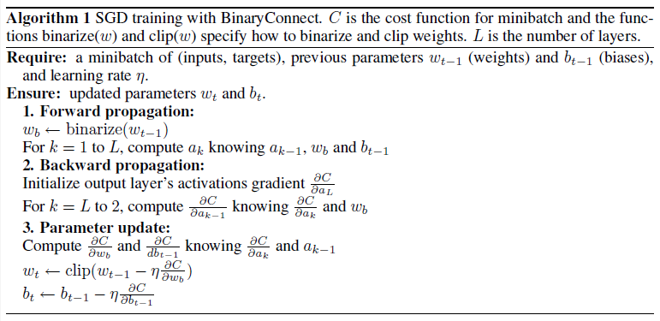

**BNN-2016**

Courbariaux M, Hubara I, Soudry D, et al. Binarized neural networks: Training neural networks with weights and activations constrained to+ 1 or− 1[J]. arXiv preprint arXiv:1602.02830, 2016.

Deterministic binarization:

$$w_{b}=\left\{\begin{matrix}+1 & if w≥0 \\ -1 & otherwise\end{matrix}\right.$$

Stochastic binarization:

$$w_{b}=\left\{\begin{matrix}+1 & with probability p=σ(w) \\ -1 & with probability 1-p\end{matrix}\right.$$

$$σ\left(x\right)=clip\left(\frac{x+1}{2},0,1\right)=max⁡(0,min⁡(1,\frac{x+1}{2}))$$

Backpropagation

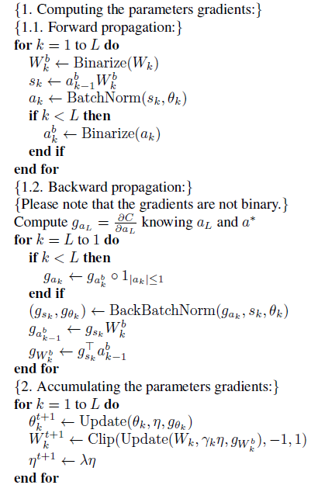

**BNN-2016**

Kim M, Smaragdis P. Bitwise neural networks[J]. arXiv preprint arXiv:1601.06071, 2016.

Real value networks with weight compression:

$$a_{i}^{l}=\tanh\left({\overline{b}}_{i}^{l}\right)+\sum_{j}^{K^{l-1}}{\tanh\left({\overline{w}}_{i,j}^{l}\right){\overline{z}}_{j}^{l-1}}$$

$${\overline{z}}_{j}^{l}=tanh⁡(a_{i}^{l})$$

Backpropagation:

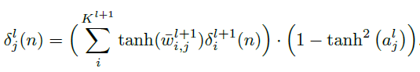

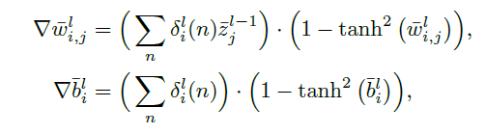

Bitwise network:

$$w_{ij}^{l}=\left\{\begin{matrix}1 & w_{ij}^{l}>β \\ 0 & \left|w_{ij}^{l}\right|≤β \\ -1 & w_{ij}^{l}<-β\end{matrix}\right.$$

Backpropagation:

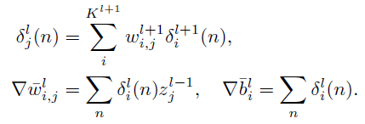

**XNOR-Net-2016**

Rastegari M, Ordonez V, Redmon J, et al. Xnor-net: Imagenet classification using binary convolutional neural networks[C]//European Conference on Computer Vision. Springer, Cham, 2016: 525-542.

Forward:

$$B=sign\left(W\right)$$

$$α=\frac{1}{n}{\left\|W\right\|}_{l_{1}}$$

backward:

$$\frac{∂C}{∂W_{i}}=\frac{∂C}{∂\tilde{W_{i}}}(\frac{1}{n}+\frac{∂sign}{∂\tilde{W_{i}}}α)$$

k-bit Quantization:

$$q_{k}\left(x\right)=2(\frac{\left[\left(2^{k}-1\right)\left(\frac{x+1}{2}\right)\right]}{2^{k}-1}-\frac{1}{2})$$

**DoReFa-Net-2016**

Zhou S, Wu Y, Ni Z, et al. DoReFa-Net: Training low bitwidth convolutional neural networks with low bitwidth gradients[J]. arXiv preprint arXiv:1606.06160, 2016.

STE(Straight-Through Estimator)

Bernoulli Sampling:

$$Forward:q\sim Bernoulli(p)$$

$$Backward:\frac{∂c}{∂p}=\frac{∂c}{∂q}$$

In DoReFa-Net:

$$Forward:r_{o}=\frac{1}{2^{k}-1}round(\left(2^{k}-1\right)r_{i})$$

$$Backward:\frac{∂c}{∂r_{i}}=\frac{∂c}{∂r_{o}}$$

In BNN:

$$Forward:r_{o}=sign(r_{i})$$

$$Backward:\frac{∂c}{∂r_{i}}=\frac{∂c}{∂r_{o}}1_{\left|r_{i}\right|≤1}$$

In XNOR-Net:

$$Forward:r_{o}=sign\left(r_{i}\right)×E_{F}(|r_{i}|)$$

$$Backward:\frac{∂c}{∂r_{i}}=\frac{∂c}{∂r_{o}}1_{\left|r_{i}\right|≤1}$$

In DoReFa-Net k bit:

$$Forward:r_{o}=f_{w}^{k}\left(r_{i}\right)=2quantize_{k}\left(\frac{\tanh\left(r_{i}\right)}{2max⁡(|tanh⁡(r_{i})|)}+\frac{1}{2}\right)-1$$

$$Backward:\frac{∂c}{∂r_{i}}=\frac{∂c}{∂r_{o}}\frac{∂r_{o}}{∂r_{i}}$$